STCC_100_B – Unix basics for Bioinformatics
-Notes documented by Sthavitha Rithu LNS
This repository documents Unix command-line concepts and tools learned during the STCC course.
It focuses on file system navigation, command chaining, and practical use-cases relevant to bioinformatics workflows.
LECTURE-1
Commands discussed
COMMAND | MEANING | EXAMPLE / OUTPUT SEEN
pwd | Shows the present working directory | (base) sthavitha_rithu@Starshine:~$pwd  Output:  /home/sthavitha_rithu
ls | Lists the files and directories present in pwd | (base) sthavitha_rithu@Starshine :~ /stcc/test-project $ ls  Output:  analysis data script
mkdir | Creates a new directory | mkdir test-project
touch | Creates new file(s) | touch random.csv
echo | Prints text or variables (writes into the file) | echo “Hello World” > random.csv
cat | Displays contents inside the file | cat random.csv  Output:  Hello World
echo >> | Double quotes ensure that the previously written string is not deleted | echo “Hello India” >> random.csv  cat random.csv  Output:  Hello World  Hello India
cd .. | Change directory to one step before in the path of directory | If pwd is ) sthavitha_rithu@Starshine :~ /stcc/test-project, cd .. changes the directory to ) sthavitha_rithu@Starshine :~ /stcc
cp -t | Copies files and directories  -t stands for target | cp demo_1/random.csv -t demo 2  This copies the file ‘random.csv’ present in the directory ‘demo_1’ to the target(-t) directory ‘demo_2’
mv | Moves the files from one directory to another.  Can also be used for renaming the files | mv demo_1/random.csv demo_2  This moves the file ‘random.csv’ present in the directory ‘demo_1’ to directory ‘demo_2’  mv demo_2 test  This renames the directory ‘demo_2’ to ‘test’
rmdir | Deletes empty files and directories | rm demo_1  This deletes the directory ‘demo_1’ permanently. One needs to be careful here because unlike Windows, there is no option of ‘Recycle Bin.’ In Unix, once a file or directory is deleted, it is done permanently.
rm -rf | Deletes files and directories when there is content present in it | rm -rf test  This is force-deleting all directories and files as a superuser.
man | manual | Shows the user manual for all commands and its meaning
history | lists down all commands typed | Lists down all commands typed in the session

Reproducible and Robust research
Reproducibility and robustness are crucial in Genomic data analysis
Reproducible research:
- Sharing code and data.
- Details like software version, data version, metadata should be provided.
- Proper project planning such as what software is going to be used for the project, who is going to run the pipeline should be properly decided.
- Proper documentation of everything needs to be done.
Robust research:
- While writing the code, one should follow: commenting properly, make sure it is readable and easy to understand, should be modular, reusable and broken into compartments for better understanding.
- Make use of automation by defining functions for repetitive tasks.
- Use consistent file naming convention.
- Unit testing: ‘Letting the code test the code’ should be practiced.
Paradox of scientific coding is that scientific coding should be tested strictly to ensure quality and prevent bugs. But it is often not tested.
- Treat data as read-only. Else, it will be easy to lose track of how the data was modified.
- Develop the frequently used scripts as tools.
- Use code as documentation, a README file is equivalent to a wet-lab manual.
LECTURE-2
Commands discussed
The following commands show:
- How multiple files can be created at once using {} along with the touch command.
- How sub-setting can be done using * and []

COMMANDS | OUTPUT
echo languages-{python,r,rust} | languages-python languages-r languages-rust
touch sample{A,B,C}_R{1,2}.fastq | sampleA_R1.fastq sampleA_R2.fastq sampleB_R1.fastq sampleB_R2.fastq sampleC_R1.fastq sampleC_R2.fastq
ls sampleA* | sampleA_R1.fastq sampleA_R2.fastq
ls sample[AB]_R1.fastq | sampleA_R1.fastq sampleB_R1.fastq
ls sample[A-C]_R1.fastq | sampleA_R1.fastq sampleB_R1.fastq sample_R1.fastq

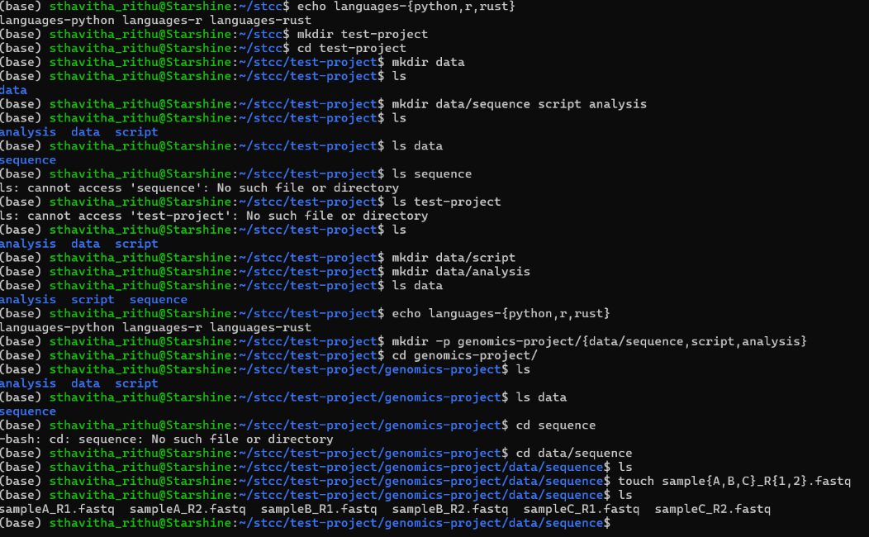
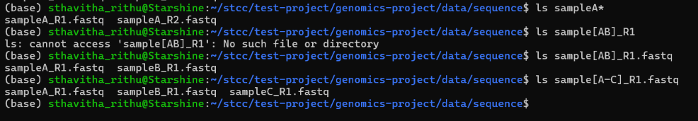
Streaming and Redirecting
Streaming - In Unix-like systems, a stream is a flow of data (a sequence of bytes) from a source to a destination, providing a universal interface for interprocess communication and input/output operations.
Bioinformatics example:
When a bioinformatician downloads FASTA files, he/she can Shift + Right click “Open Linux Shell here” to open a new terminal. Then, the user can simply give the cat command to view the contents of the file.
This is particularly useful in bioinformatics because of the huge size of the files. Streaming essentially prints file content without storing it in the device’s memory.
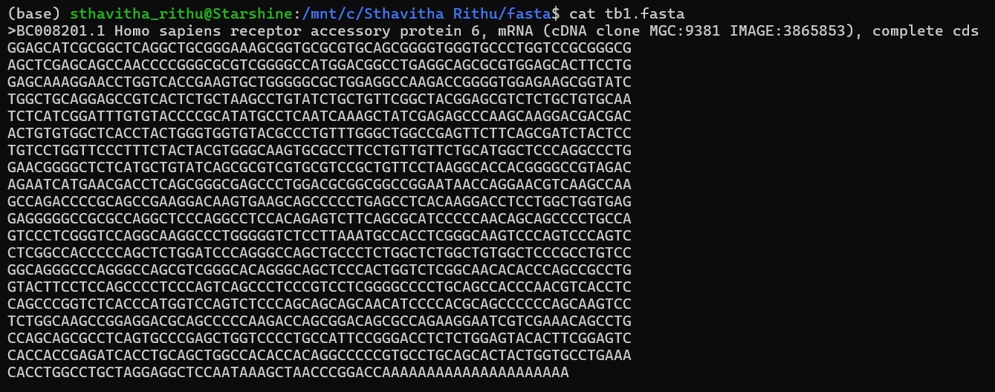
Redirecting- Redirection in Linux is a method of controlling where the input and output of commands go, allowing users to send command outputs to files or take inputs from files instead of the terminal. Common redirection operators include:
> Redirects standard output (overwrites file).
>> Redirects and appends output to a file.
2> Redirects error messages to a file.
&> Redirects both standard output and error to a file.
COMMANDS | MEANING
cat tb1_protein.fasta tb1.fasta | Contents of the files are printed fully one by one
cat tb1_protein.fasta tb1.fasta > combined.fasta | Shows all the content together in one file. This way is much easier than using other applications like Notepad from Windows.
cat tga1-protein.fasta abc.fasta > redirect.fasta | If abc.fasta does not exist, the error message will be displayed and contents of tga1-protein.fasta will be written in redirect.fasta
cat tga1-protein.fasta abc.fasta > combined.fasta 2> combined.stderr | Contents of tga1-protein.fasta gets stored in combined.fasta.  Since abc.fasta does not exist, it gets stored in combined.stderr

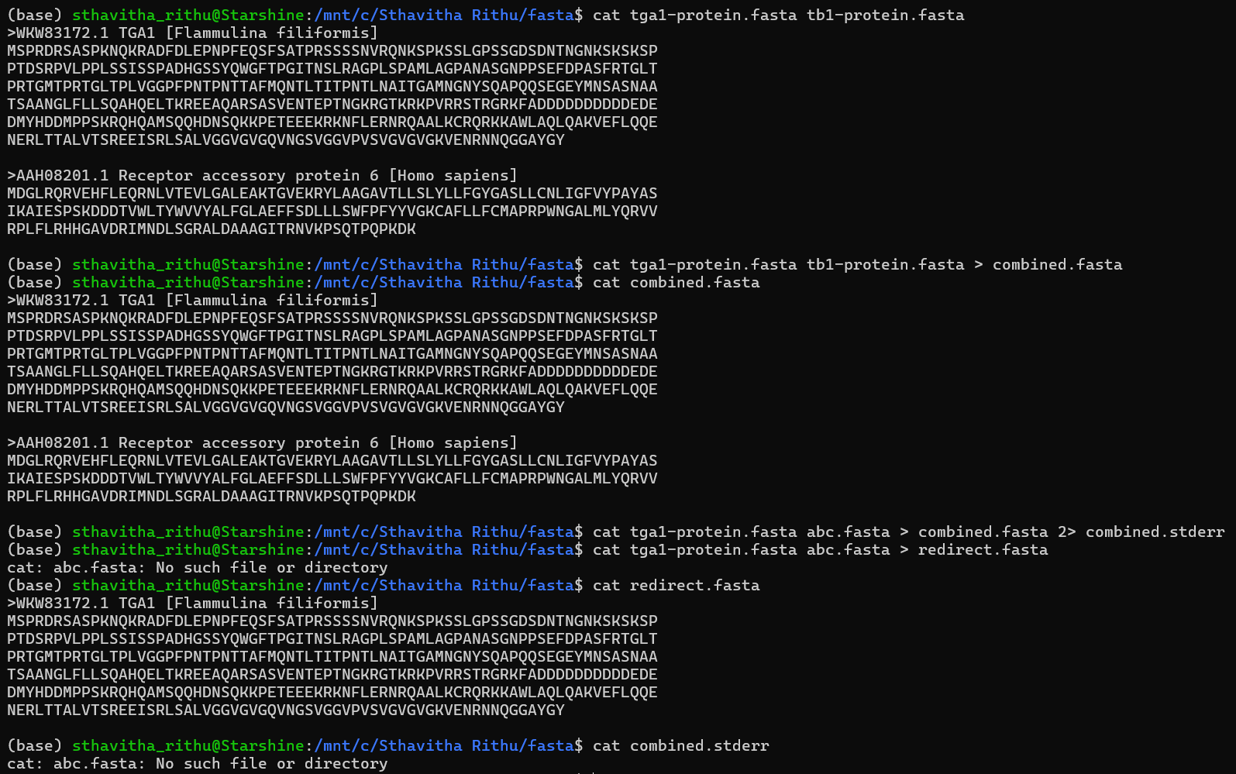
Pipe
A pipe function (|) essentially takes the output of the first command as the input of the second command and displays the output of the final command only.
COMMAND / SYMBOL USED | MEANING
grep | Regular expression pattern matching
| | pipe operator
^ | Invert matching (ignores the characters mentioned)

Bioinformatics example:
grep -v "^>" tga1-protein.fasta | grep --color "[^GPSTVEF]"
This command first removes FASTA headers (> lines) and then highlights amino acids not in the set G, P, S, T, V, E, F in the protein sequence in color.
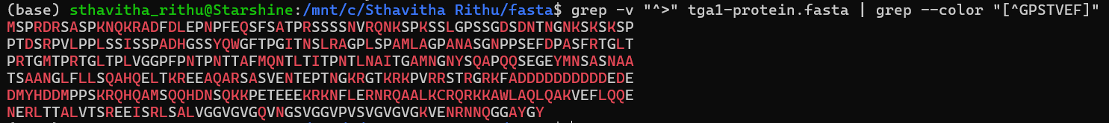

LECTURE-3
COMMAND | MEANING
cat Mus_musculus.GRCm38.75.gtf | less | Displays it in a scrollable viewer (less), so you can navigate through the file without overwhelming your terminal.
| head | Displays the first 10 lines of the file
| head -n20 | Displays the first 20 lines of the file
| tail | Displays the last 10 lines of the file
grep 'gene_id "ENSMUSG00000095742"' Mus_musculus.GRCm38.75.gtf | grep can be used to check a particular string's presence.
grep -o 'gene_id "ENSMUSG00000095742"' Mus_musculus.GRCm38.75.gtf | Finds and prints only the matching portion of the string gene_id "ENSMUSG00000095742" from the mouse annotation file, highlighting where that gene ID appears in the GTF.

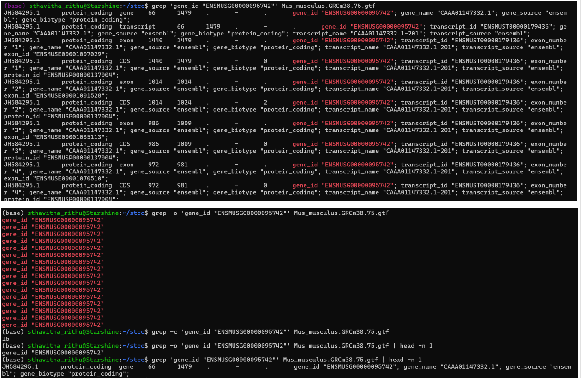
Word count
grep 'gene_id "ENSMUSG00000095742"' Mus_musculus.GRCm38.75.gtf | wc allows one to check for the word count. The first digit corresponds to the number of words, second the number of lines and third the number of characters.
One can also use the following commands to see only the count the user is interested in:
wc -w: number of words | wc -l: number of lines | wc -m: number of characters

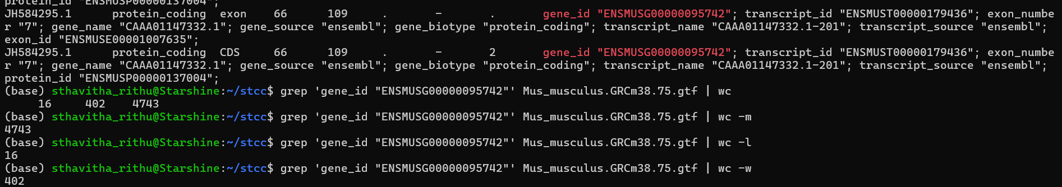

LECTURE-4
(base) sthavitha_rithu@Starshine:/mnt/c/Sthavitha Rithu/git_lecture$ git config --global user.name "sthavitha07rithu"
(base) sthavitha_rithu@Starshine:/mnt/c/Sthavitha Rithu/git_lecture$ git config --global user.email "sthavitha07rithu@gmail.com"
(base) sthavitha_rithu@Starshine:/mnt/c/Sthavitha Rithu/git_lecture$ ssh-keygen -t rsa -b 4096 -C
option requires an argument -- C
usage: ssh-keygen [-q] [-a rounds] [-b bits] [-C comment] [-f output_keyfile]
[-m format] [-N new_passphrase] [-O option]
[-t dsa | ecdsa | ecdsa-sk | ed25519 | ed25519-sk | rsa]
[-w provider] [-Z cipher]
ssh-keygen -p [-a rounds] [-f keyfile] [-m format] [-N new_passphrase]
[-P old_passphrase] [-Z cipher]
ssh-keygen -i [-f input_keyfile] [-m key_format]
ssh-keygen -e [-f input_keyfile] [-m key_format]
ssh-keygen -y [-f input_keyfile]
ssh-keygen -c [-a rounds] [-C comment] [-f keyfile] [-P passphrase]
ssh-keygen -l [-v] [-E fingerprint_hash] [-f input_keyfile]
ssh-keygen -B [-f input_keyfile]
ssh-keygen -D pkcs11
ssh-keygen -F hostname [-lv] [-f known_hosts_file]
ssh-keygen -H [-f known_hosts_file]
ssh-keygen -K [-a rounds] [-w provider]
ssh-keygen -R hostname [-f known_hosts_file]
ssh-keygen -r hostname [-g] [-f input_keyfile]
ssh-keygen -M generate [-O option] output_file
ssh-keygen -M screen [-f input_file] [-O option] output_file
ssh-keygen -I certificate_identity -s ca_key [-hU] [-D pkcs11_provider]
[-n principals] [-O option] [-V validity_interval]
[-z serial_number] file ...
ssh-keygen -L [-f input_keyfile]
ssh-keygen -A [-a rounds] [-f prefix_path]
ssh-keygen -k -f krl_file [-u] [-s ca_public] [-z version_number]
file ...
ssh-keygen -Q [-l] -f krl_file [file ...]
ssh-keygen -Y find-principals -s signature_file -f allowed_signers_file
ssh-keygen -Y match-principals -I signer_identity -f allowed_signers_file
ssh-keygen -Y check-novalidate -n namespace -s signature_file
ssh-keygen -Y sign -f key_file -n namespace file [-O option] ...
ssh-keygen -Y verify -f allowed_signers_file -I signer_identity
-n namespace -s signature_file [-r krl_file] [-O option]
(base) sthavitha_rithu@Starshine:/mnt/c/Sthavitha Rithu/git_lecture$ ssh-keygen -t rsa -b 4096 -C "sthavitha07rithu@gmail.com"
Generating public/private rsa key pair.
Enter file in which to save the key (/home/sthavitha_rithu/.ssh/id_rsa): <press Enter>
Created directory '/home/sthavitha_rithu/.ssh'.
Enter passphrase (empty for no passphrase): <press Enter>
Enter same passphrase again: <press Enter>
Your identification has been saved in /home/sthavitha_rithu/.ssh/id_rsa
Your public key has been saved in /home/sthavitha_rithu/.ssh/id_rsa.pub
The key fingerprint is:
SHA256:y8UV46eAarpCpitxFmkAE9nNcin6CgxCpWIdTkptkSo sthavitha07rithu@gmail.com
The key's randomart image is:
+---[RSA 4096]----+
|==oBo. o |
|+oX+* . . o |
|o*oB . . o . |
|E.+ . . o o |
|=o . o S o . |
|o.* o . o |
|.O . o |
|+ . . |
|o. .. |
+----[SHA256]-----+
(base) sthavitha_rithu@Starshine:/mnt/c/Sthavitha Rithu/git_lecture$ cd .ssh
-bash: cd: .ssh: No such file or directory
(base) sthavitha_rithu@Starshine:/mnt/c/Sthavitha Rithu/git_lecture$ cd ~/.ssh
(base) sthavitha_rithu@Starshine:~/.ssh$ ls
id_rsa id_rsa.pub - - it is important that you DO NOT share id_rsa anywhere. Id_rsa.pub is okay to share since it is public.
(base) sthavitha_rithu@Starshine:~/.ssh$ cat id_rsa.pub
<gives the SSH key which you need to paste in your GitHub account>
git init:
git add:
git commit -m "This is my first commit_STCC":
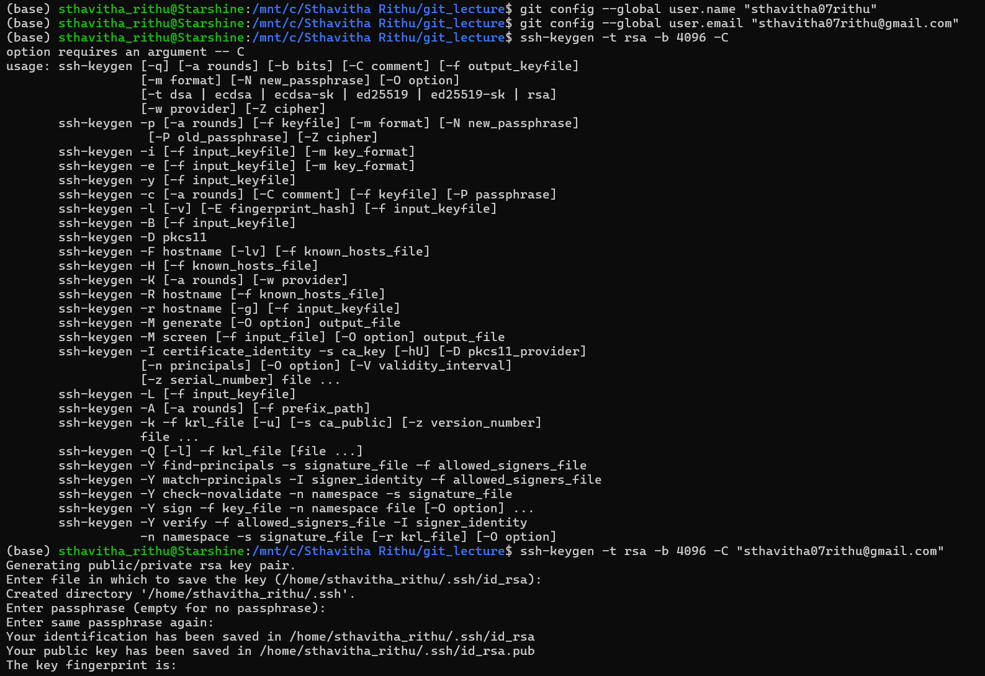
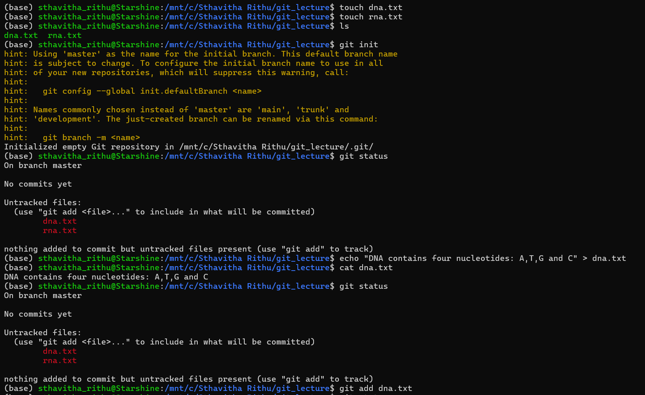
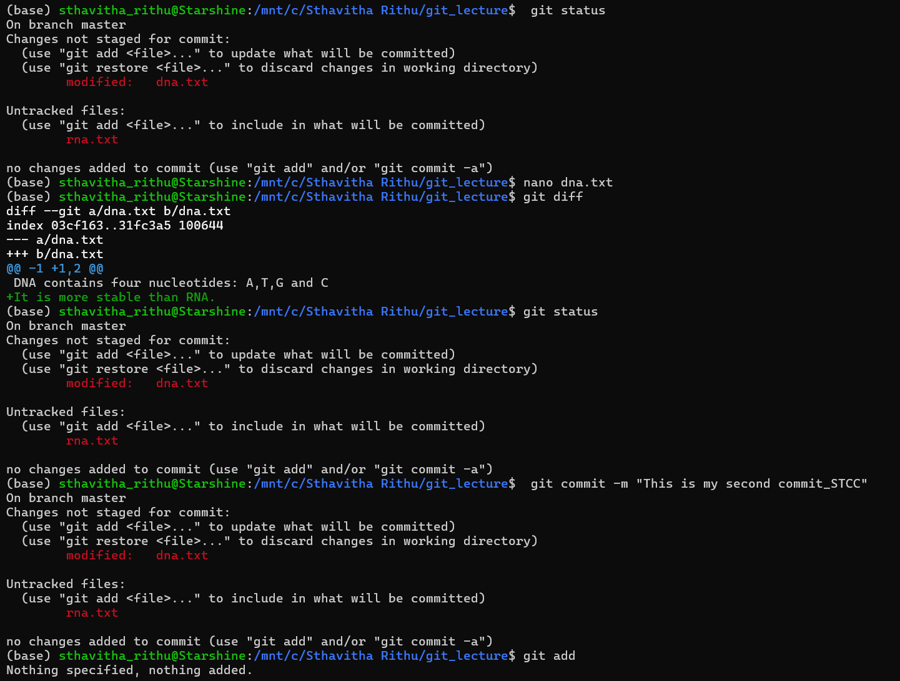
To stage a file: git add filename
To commit it: git commit -m “a comment explaining the new changes”
To check: git status
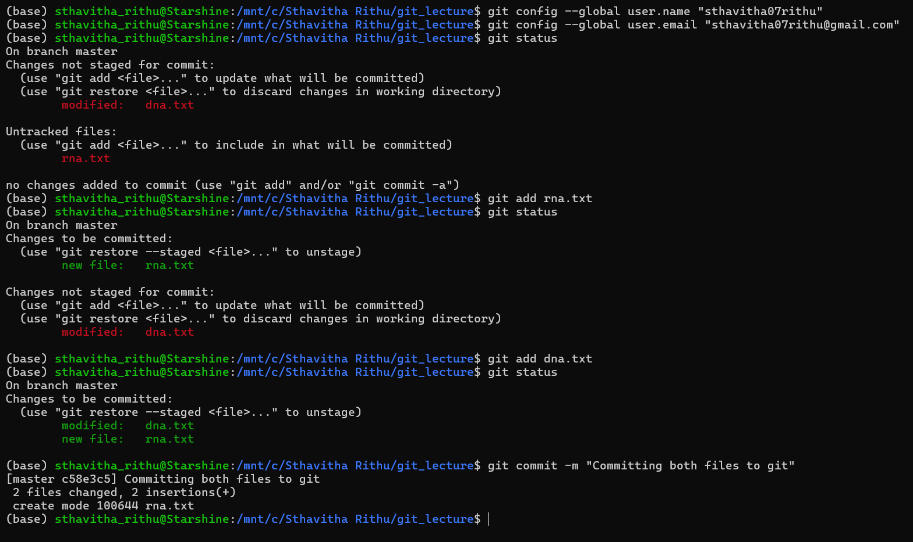
git diff: to see the difference
git log: to see the log history of commits
To go back to previous version: git restore filename
To go back to previous version when it is already staged: git restore –staged filename
To delete the file that was tracked and committed: git rm -f filename
To rename a file: git mv dna.txt dna.py
To ignore files: we first create a file called .gitignore, the dot in front says that it is a hidden file
touch .gitignore
echo “sample.fastq” >> .gitignore
--this tells git that the file sample.fastq can be ignored. So git does not worry about the new changes being made to the sample.fastq file
--the file does not even show up when we give the command git status because it is being ignored completely.

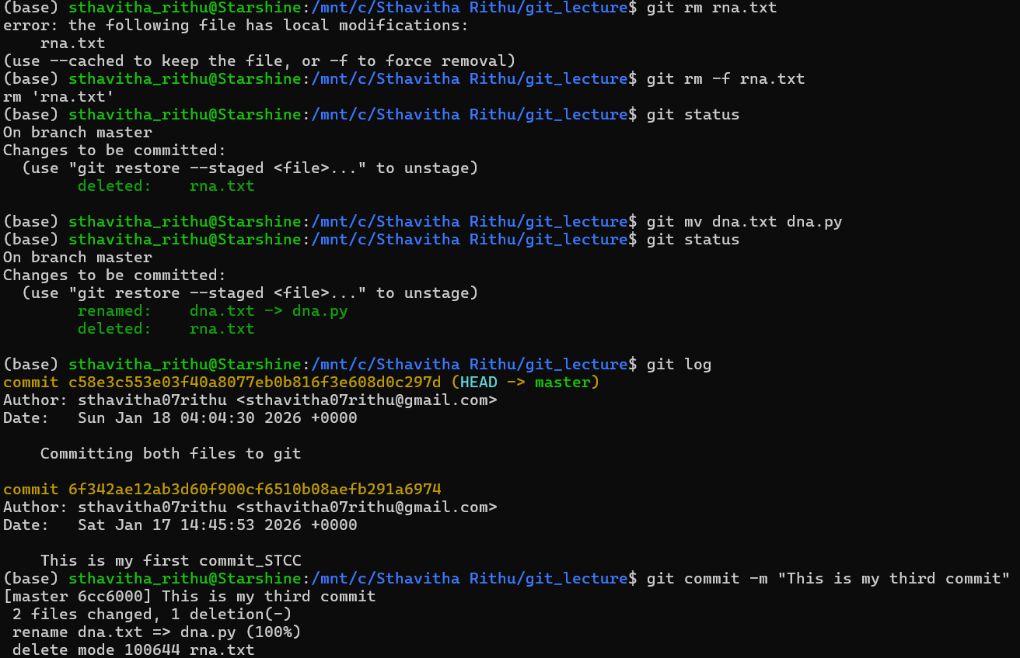
Even when we add files to .gitignore, we need to add and commit it
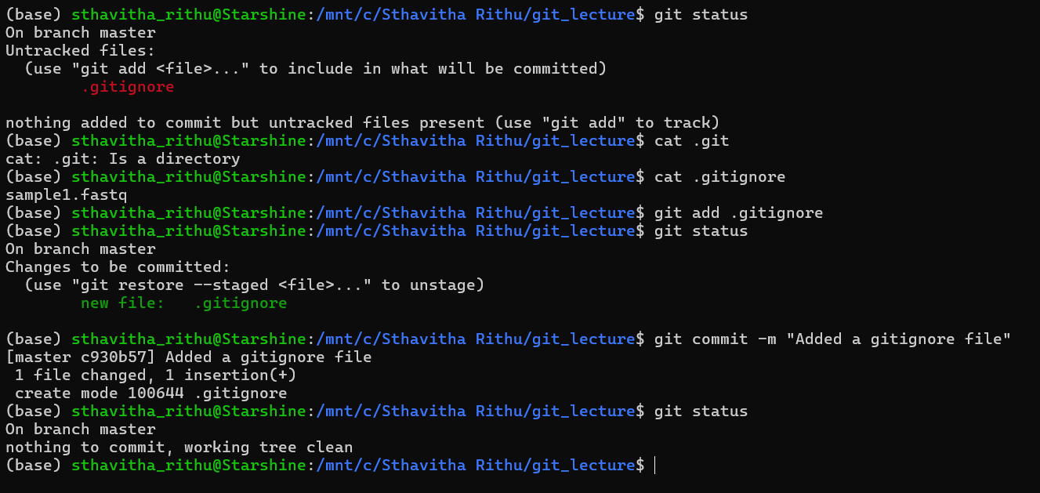
To push the exisiting repository from command line
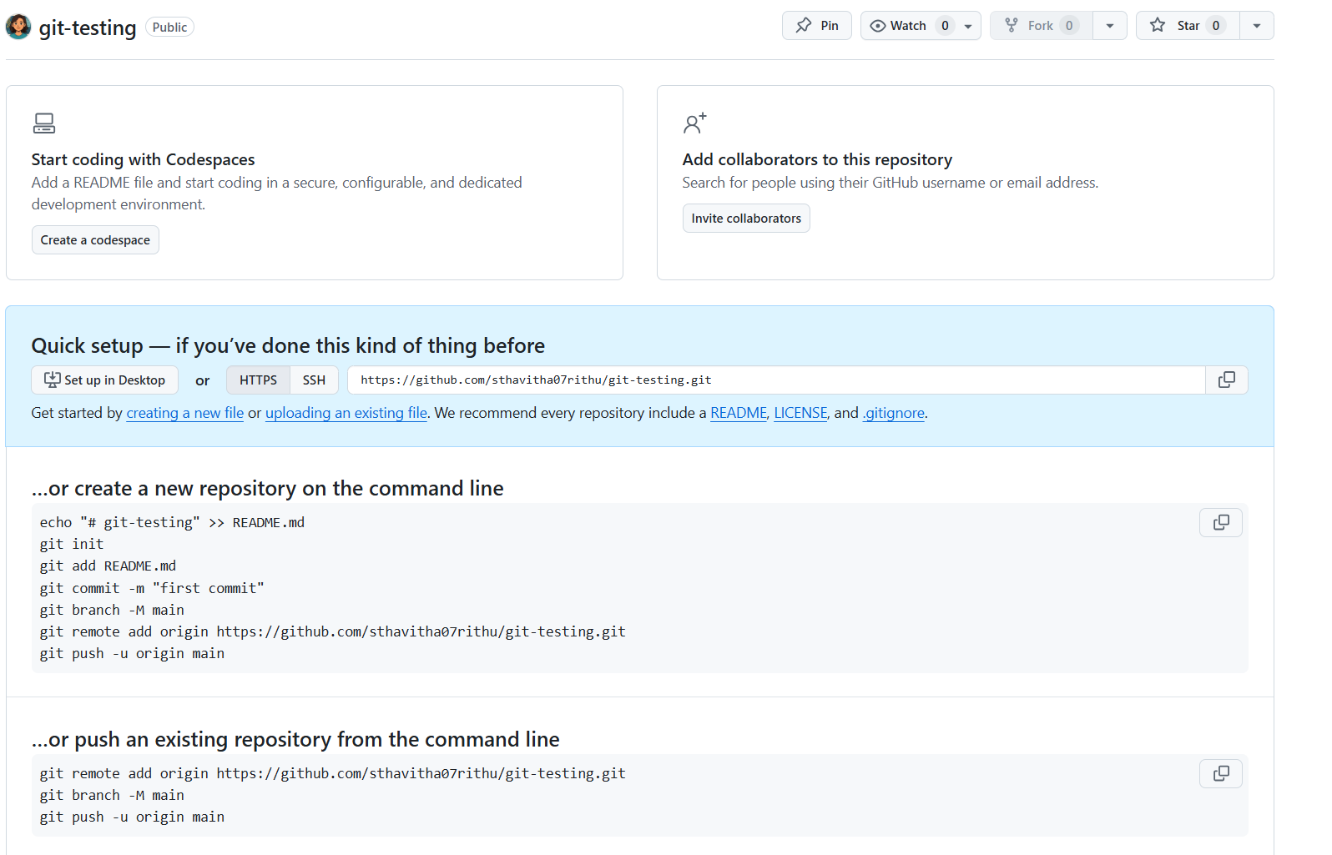
(base) sthavitha_rithu@Starshine:/mnt/c/Sthavitha Rithu/git_lecture$ git remote add origin https://github.com/sthavitha07rithu/git-testing.git
(base) sthavitha_rithu@Starshine:/mnt/c/Sthavitha Rithu/git_lecture$ git status
On branch master
nothing to commit, working tree clean
(base) sthavitha_rithu@Starshine:/mnt/c/Sthavitha Rithu/git_lecture$ git branch -M master
(base) sthavitha_rithu@Starshine:/mnt/c/Sthavitha Rithu/git_lecture$ git push origin master
Username for 'https://github.com': sthavitha07rithu
Password for 'https://sthavitha07rithu@github.com':
Enumerating objects: 12, done.
Counting objects: 100% (12/12), done.
Delta compression using up to 12 threads
Compressing objects: 100% (7/7), done.
Writing objects: 100% (12/12), 1.04 KiB | 28.00 KiB/s, done.
Total 12 (delta 0), reused 0 (delta 0), pack-reused 0
To https://github.com/sthavitha07rithu/git-testing.git
* [new branch] master -> master
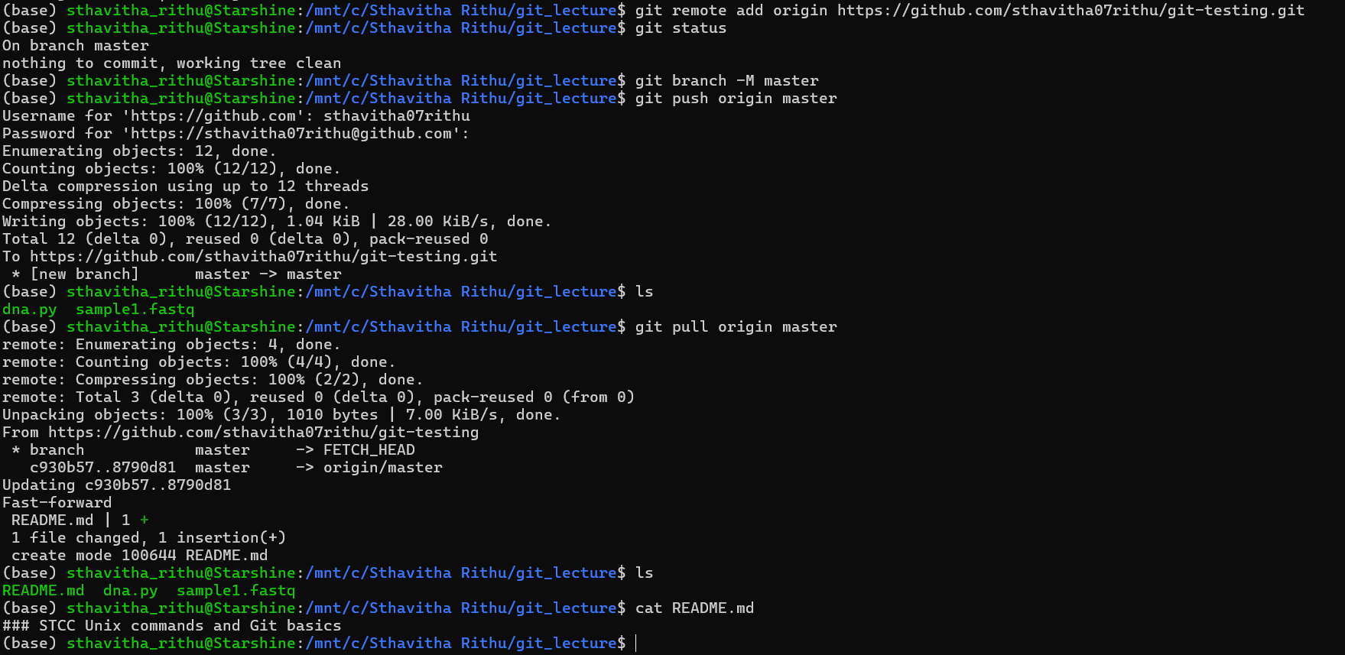
To pull from GitHub and see the files created in GitHub (in this case README.md):
(base) sthavitha_rithu@Starshine:/mnt/c/Sthavitha Rithu/git_lecture$ git pull origin master
remote: Enumerating objects: 4, done.
remote: Counting objects: 100% (4/4), done.
remote: Compressing objects: 100% (2/2), done.
remote: Total 3 (delta 0), reused 0 (delta 0), pack-reused 0 (from 0)
Unpacking objects: 100% (3/3), 1010 bytes | 7.00 KiB/s, done.
From https://github.com/sthavitha07rithu/git-testing
* branch master -> FETCH_HEAD
c930b57..8790d81 master -> origin/master
Updating c930b57..8790d81
Fast-forward
README.md | 1 +
1 file changed, 1 insertion(+)
create mode 100644 README.md
(base) sthavitha_rithu@Starshine:/mnt/c/Sthavitha Rithu/git_lecture$ ls
README.md dna.py sample1.fastq
(base) sthavitha_rithu@Starshine:/mnt/c/Sthavitha Rithu/git_lecture$ cat README.md
### STCC Unix commands and Git basics
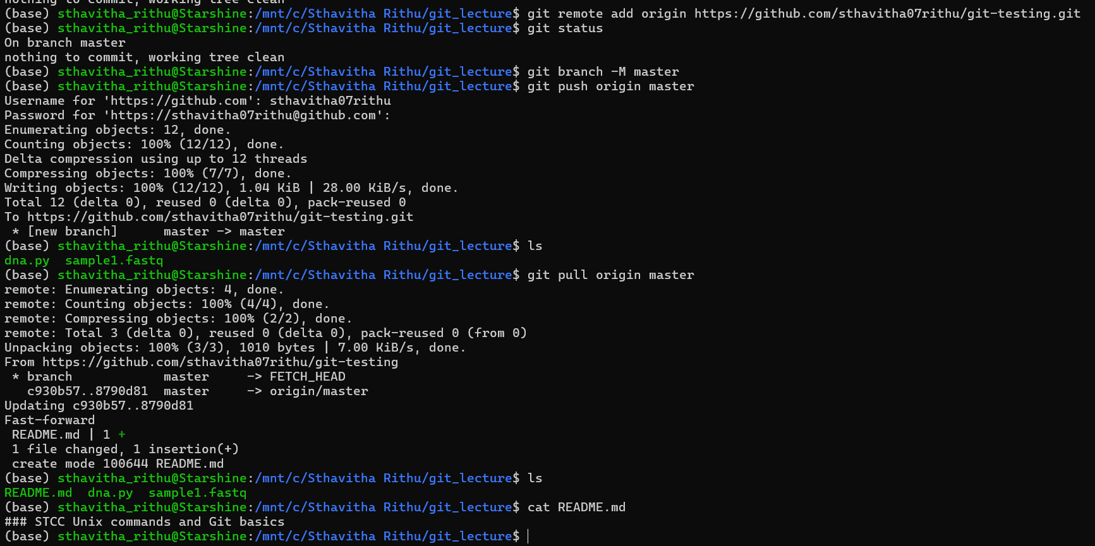
To clone the repository in another location (different drive / different laptop)
GitHub repository Code copy the https link In terminal: git clone https link
Example: git clone https://github.com/sthavitha07rithu/git-testing.git
This creates a folder in the new location with all files in it, allowing a new person to work on it from their device.
LECTURE-5
In bioinformatics, the files that we generally receive are called ‘Tabular plain text data format’ that have rows x columns.
- They are extensively used in computational analysis.
- Delimiter is how the data is separated into rows and columns. It can be separated by tab or comma or space.
File formats
.bed = contains genomic regions
COMMANDS | OUTPUT
head chr20_100kb_windows.bed | Gives top 10 rows and columns
tail chr20_100kb_windows.bed | Gives last 10 rows and columns
head -n 5 chr20_100kb_windows.bed | Gives top 5 rows and columns
(head -n 3 < chr20_100kb_windows.bed; tail -n 3 < chr20_100kb_windows.bed) | Gives top 3 and last 3 rows and columns

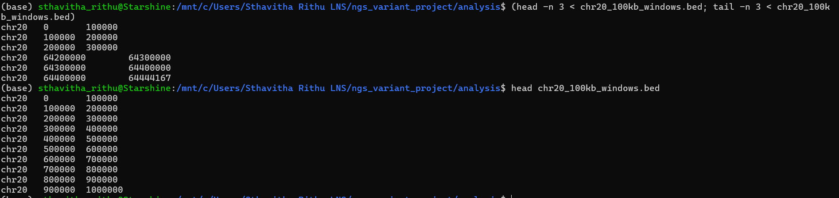
To cut columns and work with only few files:
cut -f 2 chr20_100kb_windows.bed | head -n 3
-f 2 says only 2nd column. This can be in ranges too example (-f 3-8)
.gtf = gene transfer format
grep -v "^#" Mus_musculus.GRCm38.75.gtf | cut -f1,4,5 | head -n 3
This command first takes the .gtf file, finds and ignores the contents starting with # (with -v "^#"). Then, -f1 tells cut to grab the first column. Combined with -f4,5, it extracts chromosome, start, and end coordinates from the GTF file. head prints only first 3.
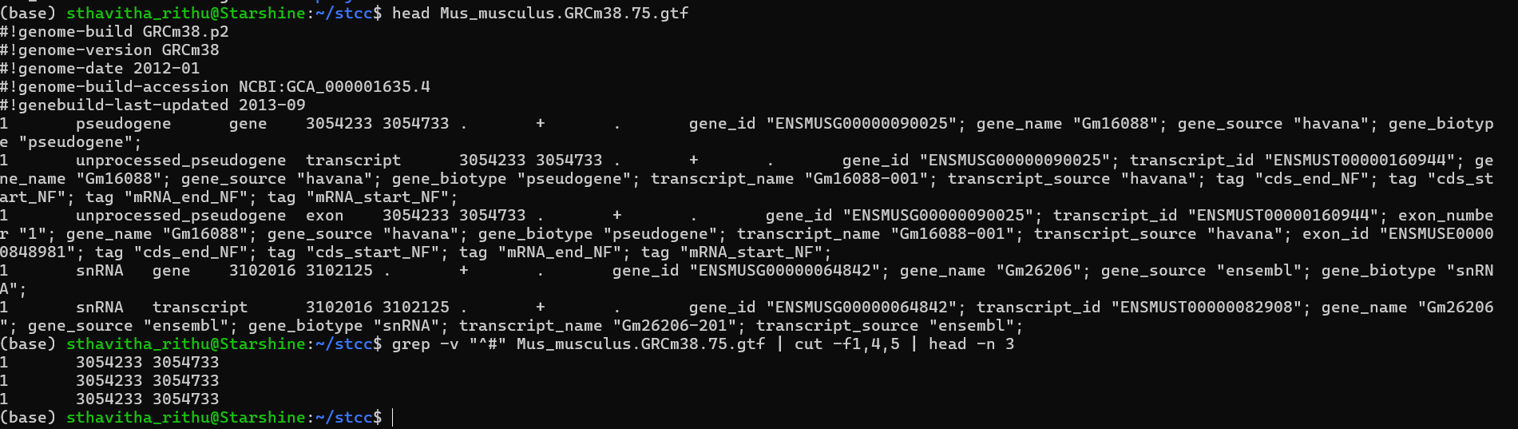
grep -v "^#" Mus_musculus.GRCm38.75.gtf | cut -f1-8 | head -n 3 shows the results but it is still hard to understand. To tackle this one can align the columns using column -t
grep -v "^#" Mus_musculus.GRCm38.75.gtf | cut -f1-8 | head -n 3 | column -t
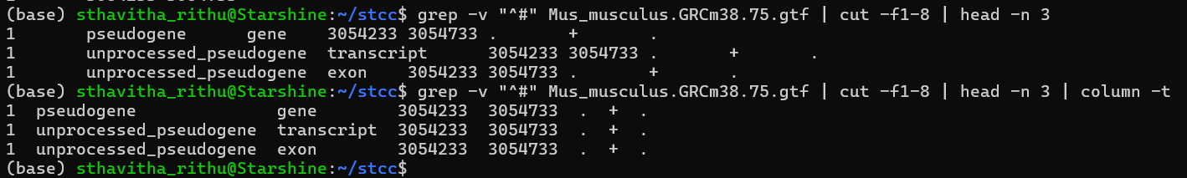
The default delimiter is tab. But when you want to use others (like comma), use -s “the delimiter you want to use for separating”.
column -s "," -t Mus_musculus.GRCm38.75.gtf | head -n 3
.txt = text format
grep “MLPH” genes.txt – to find the string MLPH in the files genes.txt
When the string we are looking for is not mentioned within the double-quotes, it returns every matching term:
Example: grep ENSG000001 genes.txt
This gives every string that starts with ENSG000001.
To ignore a particular string: grep ENSG000001 genes.txt | grep -v "ENSG00000173467"
This shows every string that starts with ENSG000001 but does not show ENSG00000173467.
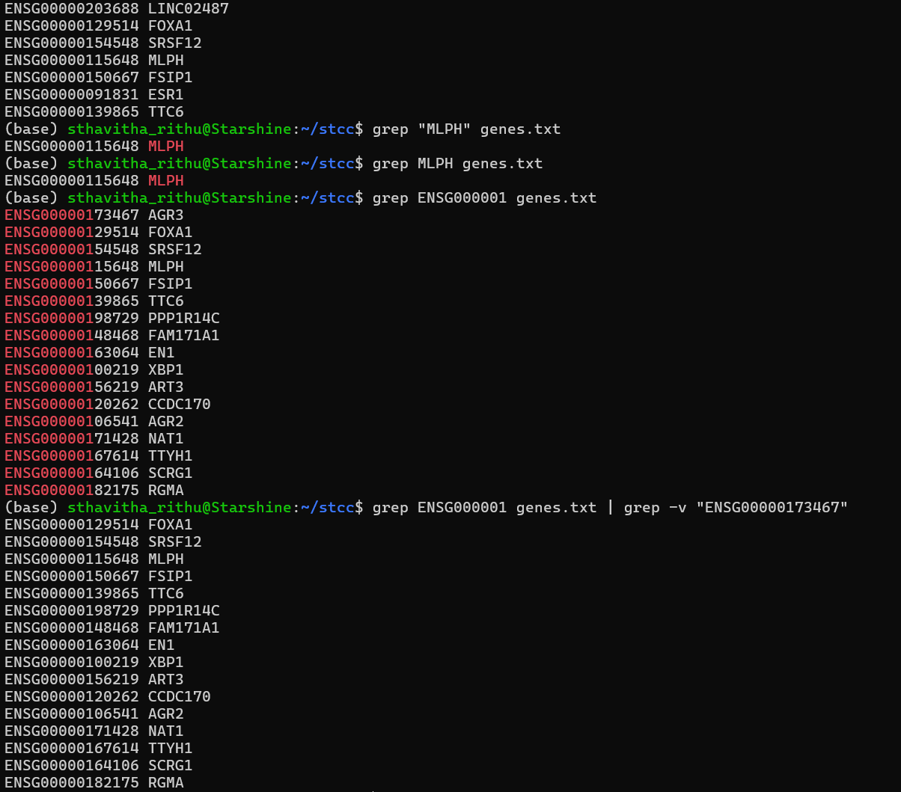

-A, -B and -C with grep:
-A NUM (After context): Shows the matching line plus NUM lines after it.
-B NUM (Before context): Shows the matching line plus NUM lines before it.
-C NUM (Context both sides): Shows the matching line plus NUM lines before and after.
Example:
grep --color=always -B1 "TACTTG" SRR15006374_1.fastq | head -n 6: This shows the matched line (containing "TACTTG") and the line just before it — typically the read ID in FASTQ format. (-B is for before)
grep --color=always -A2 "TACTTG" SRR15006374_1.fastq | head -n 6: This shows the matched line and the next 2 lines — likely the quality score line and possibly the next read header if the match is near the end of a read block. (-A is for after)
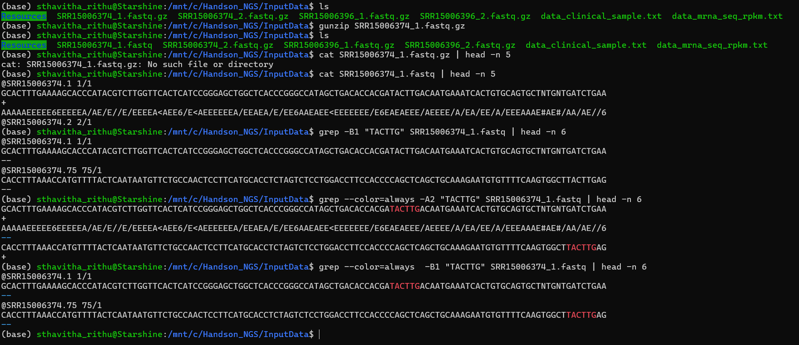
To check for either one of the strings:
grep "FOX[AC]" genes.txt FOX[AC] is a shorthand for “FOX followed by A or C.”
grep -E "(FOXC|FOXA)" genes.txt "(FOXC|FOXA)" is a full alternation that can match those substrings even inside longer gene names. (-E says matches either this or that)
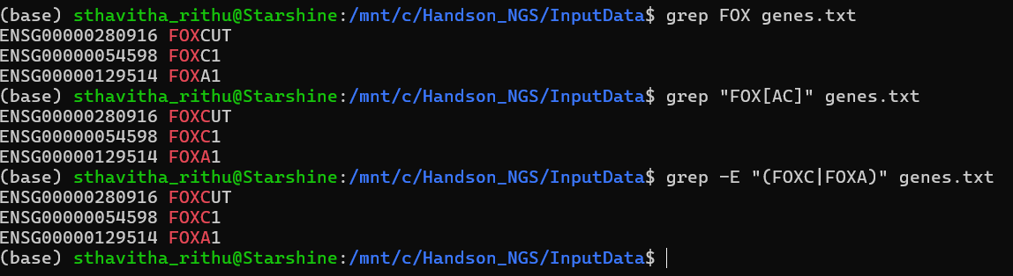
To count the strings with exact pattern, use grep -c
grep -c "FOXC" genes.txt | wc for word count
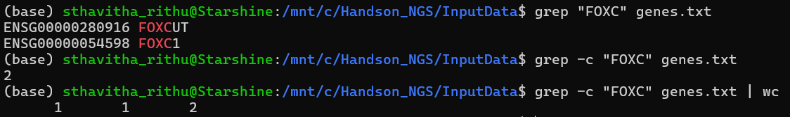

To sort, use sort filename. This sorts the content in ascending order.
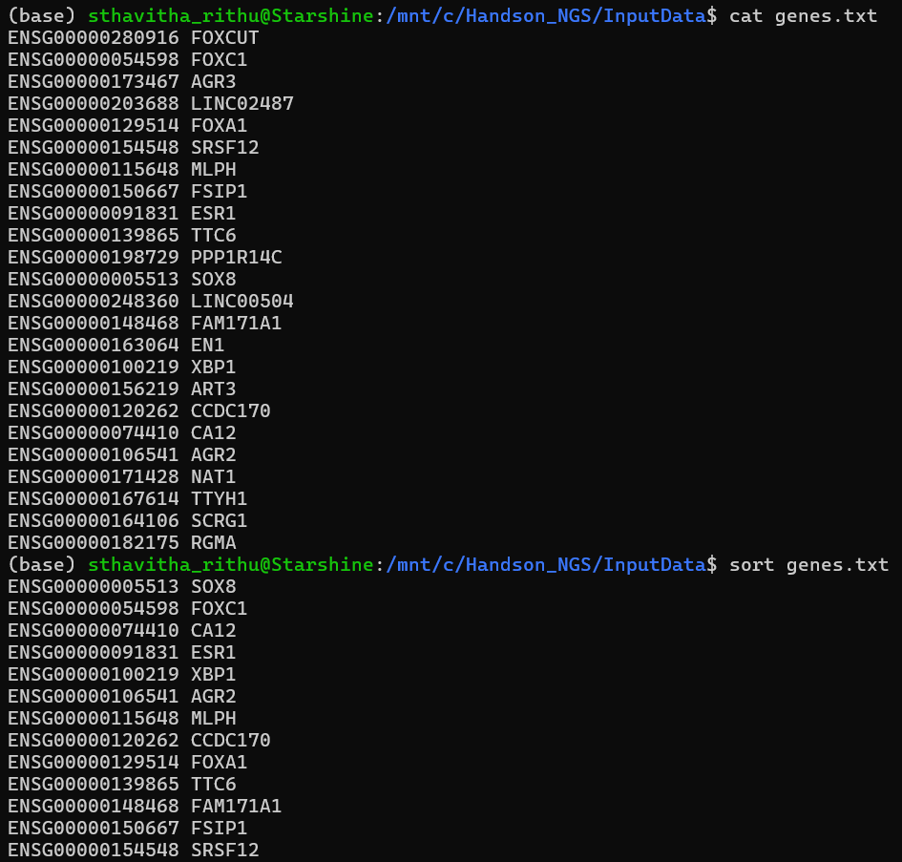
Sort controlling which columns
COMMAND | TO BE USED FOR | EXAMPLE
-k1,1 | Sort by the first column (lexicographically by default) | Sort by Ensembl gene IDs
-k2,2 | Sort by the second column alphabetically (lexicographic sort) | Sort by gene symbols like FOXC1, SOX8
-k2,2n | Sort by the second column numerically (only works if column contains numbers) | Sort by numeric values like gene lengths

To get the unique lines, we need to sort the data and apply uniq:
sort letters.txt | uniq
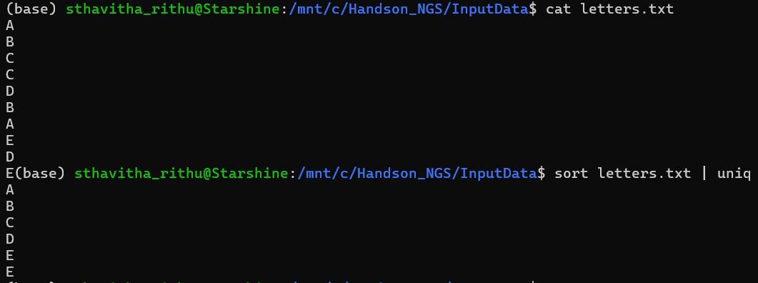
To sort and count: sort letters.txt | uniq -c
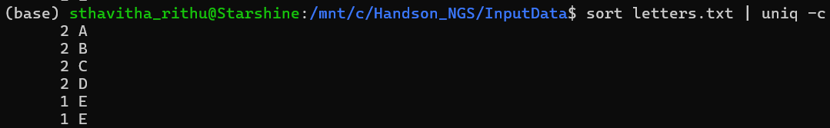

Pipeline example:
grep -v "^#" Mus_musculus.GRCm38.75_chrl.gtf| cut -f3|sort |uniq -c
- Removes header/comment lines (those starting with #) from the GTF file
- Extracts the third column, which typically contains the feature type (e.g., gene, exon, transcript).
- Sorts the feature types alphabetically so duplicates are adjacent.
- Counts how many times each feature type appears.
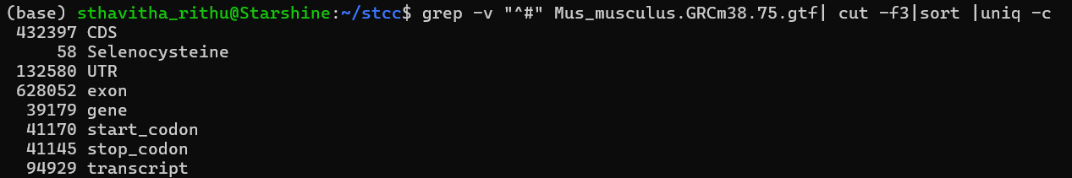
Joining two files using a common column
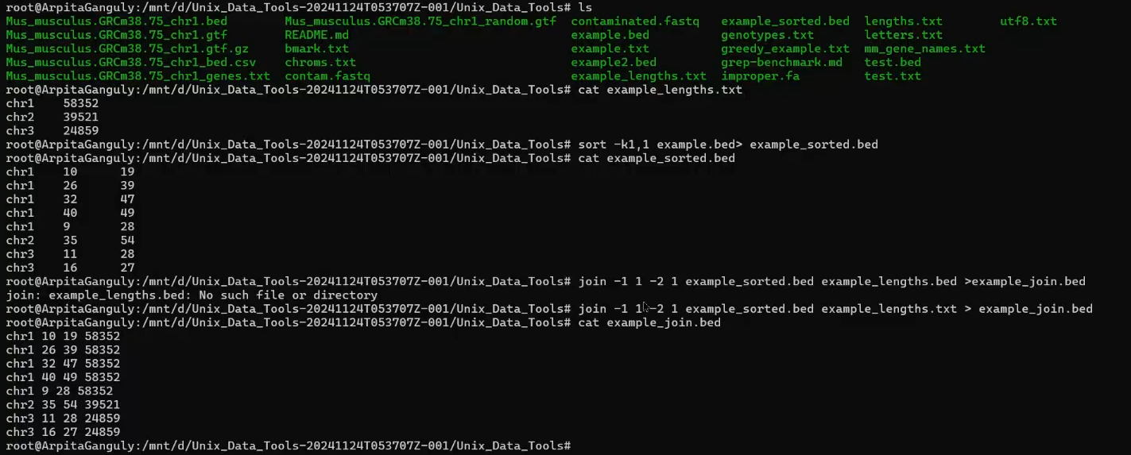
- The working directory contains multiple genomics-related text files, including BED files and chromosome length files.
- The file example_lengths.txt is inspected using cat, showing chromosome identifiers (chr1, chr2, chr3) and their corresponding lengths.
- The file example.bed is sorted by the first column (chromosome name) using sort -k1,1 example.bed > example_sorted.bed
- This produces example_sorted.bed, where genomic intervals are ordered chromosome-wise.
- The sorted BED file is displayed to confirm the correct ordering.
- The join command is then executed: join -1 1 -2 1 example_sorted.bed example_lengths.txt > example_join.bed

- This joins the two files on the first column (chromosome name).
- The resulting file example_join.bed is displayed, showing each BED interval augmented with the corresponding chromosome length.
In bioinformatics, many commonly used file formats do not include explicit column headers. This is because these formats follow well-established standards, and the meaning of each column is generally understood and consistently interpreted within the community. Detailed descriptions of the file structure and column definitions are therefore typically provided in accompanying documentation, such as GitHub repositories, official format specifications, or project websites, rather than within the data files themselves.

